# Sahi OS – Mini Exercise – Chris O’Brien

Step : 1 Open Sahi Application

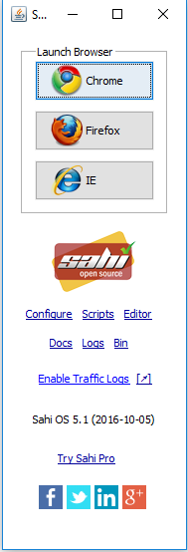

Configure: Add New Browsers for use with testing as well as adding custom user extensions

Brower’s can be added

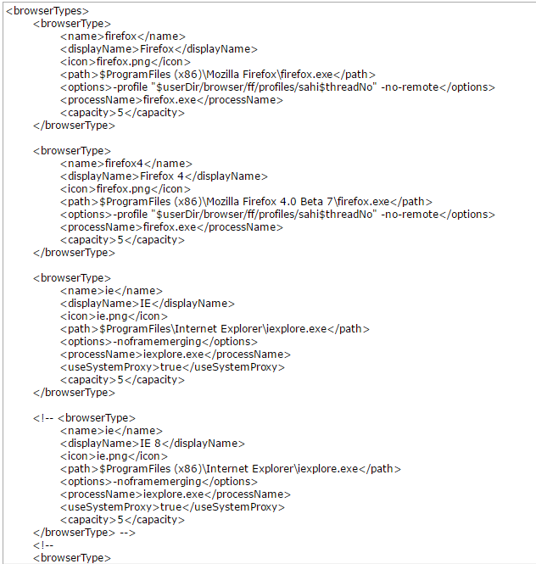

Logs: View the returned logs from tests that have been ran.

Example Log:

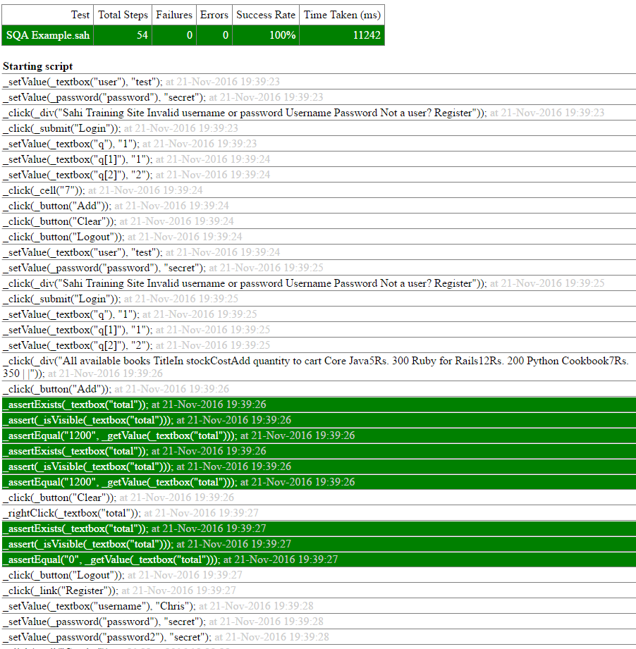

The log shows a step by step run through of the test. The steps with Green backgrounds are for evaluating expressions and ensuring that the value outputted is equal to what it should be.

Sahi Controller:

To open the controller, select a browser from the application. It will open a new browser window and sets a proxy for the script injection. It will open the Sahi home page. To open the controller hold alt key and double click the page.

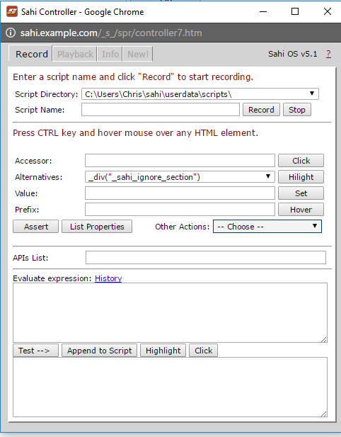

# Mini Exercise

* Step 1: Open Sahi and select a browser.
* Enter the URL for testing and press go.
* Alt + double click to bring up controller.
* Name a script and press record.
* Perform actions like normal and they will be recorded automatically
* To ensure an out is equal to what it should be hold control key and hover over the element and it will display in the controller
* Change the value and press assert and then amend to script

To playback the script:

* Go to playback tab in the SAHI Controller
* Select the file and enter a start URL for the script beginning page and press set.
* Once the page refreshes the script is ready to run.
* You can either run the script all the way through by pressing play script.
* Or alternatively you can run step by step by clicking the step button.

*In-depth Example executed in slides with screenshots.

## How does it apply to us?

Sahi is a very powerful and underrated testing tool as it has many inbuilt APIS and support for custom libraries such as Googles Polymer project which allows users to create their own HTML elements under the shadow – Dom(An encapsulation of the Browser’s DOM(Document object Model)) as well as reading PDF and excel files. Sahi Open Source is also very useful and has support for most browsers, including mobile browsers.

* SAHI is a really easy and powerful testing tool with support for a wide variety of browsers and great support for mobile over a local connection.
* Scripts are written in native JavaScript syntax which reduces the learning curve by a lot for those who have experience in the language and the frameworks APIS are really easy to use.
* Has support for complex use cases through JavaScript functions.
* Has great Jenkins integration for test automation (Distributed testing on pro version could be done with the open source version through Jenkins)

References:

<https://sahipro.com/docs/using-sahi/quick-tutorial.html> Sahi Documentation

<http://agileindia.org/uploads/downloads/Sahi.pdf>

<https://www.youtube.com/watch?v=vjxzSlUO99U>

https://www.youtube.com/watch?v=S_QSjgr-lDM